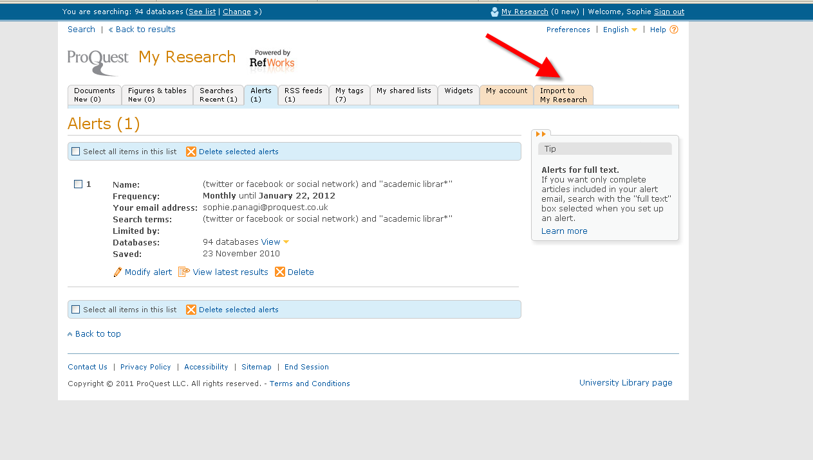

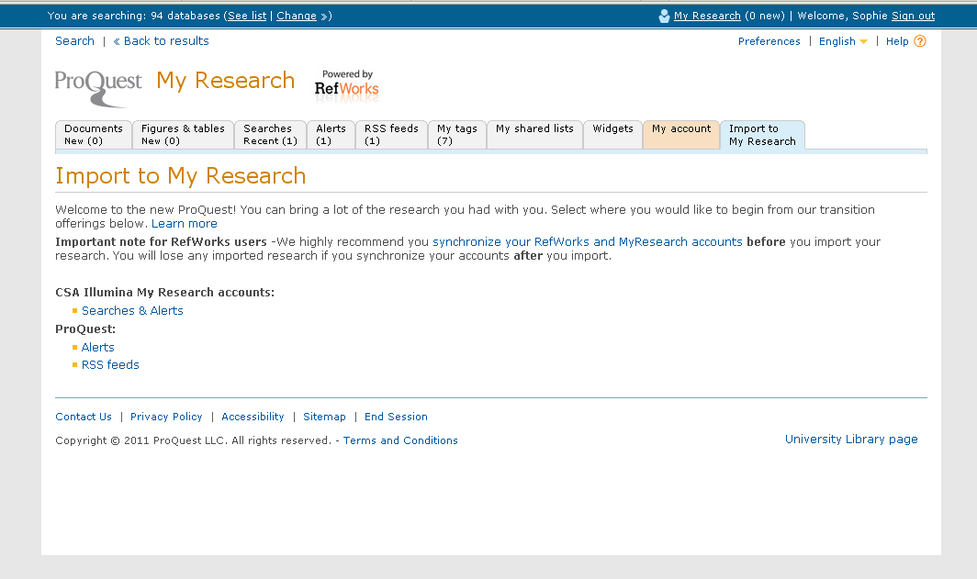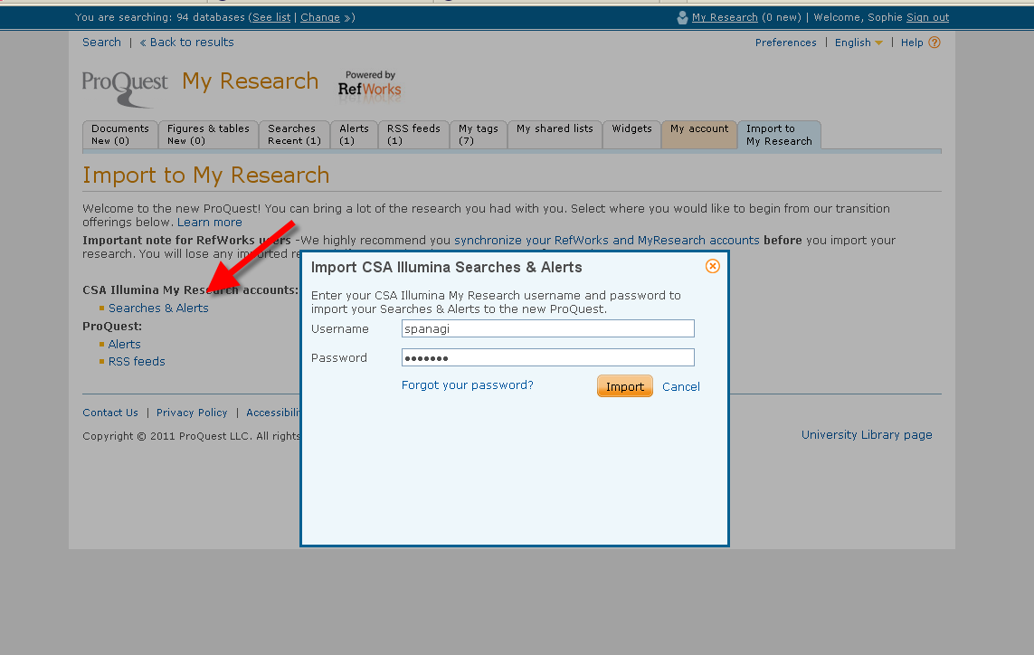

- Guiess: http://proquest.libguides.com
- Videos a Youtube: www.proquest.com/go/platformvideos
- Webinars: http://www.proquest.com/go/webinars

